Karnaugh maps
John F. Wakerly – Digital Design. 4th edition. Chapter 4.

- Goal – Represent the technic of Boolean functions minimization.
- Learning outcome - by the end of this class the students should be able to minimize any 4 variable Boolean function by Karnaugh map and Boolean equations.

Introduction
So far we can see that applying Boolean algebra can be awkward in order to simplify expressions.
The minimization method using Boolean Algebra, apart from being laborious and requiring the remembering all the laws, can lead to solutions which, though they appear minimal, are not.

The Karnaugh map provides a simple and straight-forward method of minimizing Boolean expressions. With the Karnaugh map Boolean expressions having up to four and even six variables can be simplified.

So what is the Karnaugh map?
- A Karnaugh map is a graphical representation of a logic function’s truth table.
- A Karnaugh map is a special comfortable arrangement of a truth table.
- A Karnaugh map provides a pictorial method of grouping together expressions with common factors and therefore eliminating unwanted variables.

The rows and columns of a Karnaugh map are labeled so that the input combination for any cell is easily determined from the row and column headings for that cell.

The diagram below illustrates the correspondence between the Karnaugh map and the truth table for the general case of a two variable problem.

Second order Karnaugh map.
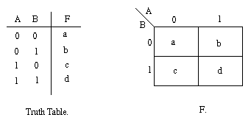
c
b
Map Coordinates (Variables’ Values)
Map Cells or Squares (Function’s values)
Karnaugh Map of the same function
of some function

The values inside the squares are copied from the output column of the truth table, therefore there is one square in the map for every row in the truth table. Around the edge of the Karnaugh map are the values of the two input variable. A is along the top and B is down the left hand side. The diagram below explains this:
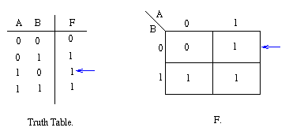
The values around the edge of the map can be thought of as coordinates. So as an example, the square on the top right hand corner of the map in the above diagram has coordinates A=1 and B=0. This square corresponds to the row in the truth table where A=1 and B=0 and F=1. Note that the value in the F column represents a particular function to which the Karnaugh map corresponds.

If we speak in minterm language then the Karnaugh map includes the minterms in this order.
 | A’ | A
B’ | m0 00 | m2 10
B | m1 01 | m3 11

Example 1:
Consider the following map. The function plotted is: Z = f(A,B) = A + AB
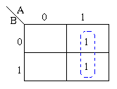
The two adjacent 1's are grouped together. Through inspection it can be seen that variable B has its true and false form within the group. This eliminates variable B leaving only variable A which only has its true form. So Z depends only on A not B. The minimized answer therefore is Z = A.
Adjacent Cells are grouped by function’s “1” value.

Using algebraic simplification,
Z = A + AB
Z = A( + B)
Z = A
Variable B becomes redundant.
- Note that values of the input variables form the rows and columns. That is the logic values of the variables A and B (with one denoting true form and zero denoting false form) form the head of the rows and columns respectively.
- The above map is a one dimensional type which can be used to simplify an expression in two variables.
- There is a two-dimensional map that can be used for up to four variables, and a three-dimensional map for up to six variables.
Example 2:
Consider the expression Z = f(A,B) = + A + B plotted on the Karnaugh map:
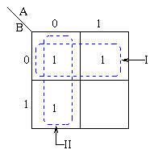
Pairs of 1's are grouped as shown above, and the simplified answer is obtained by using the following steps:
- With 2 variables the largest rectangular clusters that can be made, consist of two 1s.
- A 1 can belong to more than one group.

- The first group labeled I, consists of two 1s which correspond to A = 0, B = 0 and A = 1, B = 0.
- So the value B=0 (B’- Not B) defines this rectangle completely. The value of “A” is not important in this case because independent of the A’s value Z is always 1 when B=0.

- The group labeled II corresponds to the area of the map where A = 0. The group can therefore be defined as . This implies that when A = 0 the output is 1 independent of B

- The output is therefore 1 whenever B = 0 or A = 0
- Hence the simplified answer is Z = +
- Z = + A + B = B’ + A’B = B’ + A’
The simplified answer is Z = +

Note that two groups can be formed for the example given above, bearing in mind that the largest rectangular clusters that can be made consist of two 1s. Notice that a 1 can belong to more than one group.
The first group labeled I, consists of two 1s which correspond to A = 0, B = 0 and A = 1, B = 0. Put in another way, all squares in this example that correspond to the area of the map where B = 0 contains 1s, independent of the value of A. So when B = 0 the output is 1. The expression of the output will contain the term
For group labeled II corresponds to the area of the map where A = 0. The group can therefore be defined as . This implies that when A = 0 the output is 1. The output is therefore 1 whenever B = 0 and A = 0
Hence the simplified answer is Z = +
Third order Karnaugh map
To deal with 3 variables we need to use third order Karnaugh map.

 | A’0 |  | A1
B’0 | 000 | 001 | 101 | 100
B 1 | 010 | 011 | 111 | 110
 | C’0 | C 1 |  | C’0

Adjacent cells

The minterms are distributed in other order. The leftmost and rightmost columns’ cells are adjacent cells so can be grouped.

Example 3:
For the following truth table let’s create the Karnaugh map directly from the truth table.

Group 1  Group 2
  A B C  0 0 0  0 0 1  0 1 0  0 1 1  1 0 0  1 0 1  1 1 0  1 1 1 | Z (A,B,C)  0  1  0  0  1  1  1  1
   | A’ |  | A
  B’ |  | 1 | 1 | 1
  B |  |  | 1 | 1
   | C’ | C |  | C’
Appropriate to the map we have two groups and therefore the following minimized expression:
Z = C B’+ A

Z = A’B’C+ AB’C’+AB’C+ABC’+ABC =
A’B’C + AB’(C’+C)+AB(C’+C) =
A’B’C+ AB’+AB =
A’B’C +A(B’+B) =
A’B’C +A =
CB’+A

Example 4:
Group 1  Group 2
  A B C  0 0 0  0 0 1  0 1 0  0 1 1  1 0 0  1 0 1  1 1 0  1 1 1 | Z (A,B,C)  1  0  0  0  1  1  1  1
   | A’ |  | A
  B’ | 1 |  | 1 | 1
  B |  |  | 1 | 1
   | C’ | C |  | C’

Appropriate to the map we have the following minimized expression:
Z = C’ B’+ A

Fourth order Karnaugh map (K-map)
Fourth order Karnaugh map allows us to minimize 4 D, C, B, A variable functions.
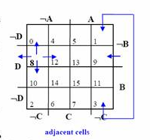
Adjacent cells
- Following the same development as before the input variables’ values have to be placed at both coordinate axes. The coordinates are labeled with A through D.
- Each cell in the K-map has a number assigned to it that is the decimal equivalent of the binary coordinates for that cell.
- Each cell has four other cells that are logically adjacent to it, i.e. the neighbours of cell 8 are cells 0,12,10,9. Thus wrap-around at all four edges has to be implemented.

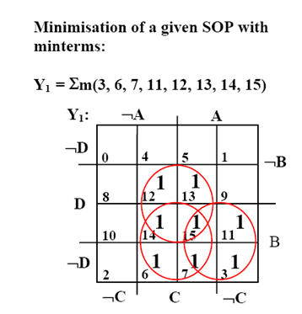

Y1 = CD + CB + BA

D C B A  0 0 0 0  0 0 0 1  0 0 1 0  0 0 1 1  0 1 0 0  0 1 0 1  0 1 1 0  0 1 1 1  1 0 0 0  1 0 0 1  1 0 1 0  1 0 1 1  1 1 0 0  1 1 0 1  1 1 1 0  1 1 1 1 | Z(D,C,B,A)  0  0  0  1  0  0  1  1  0  0  0  1  1  1  1  1
Y1 = D’C’BA+ D’CBA’+ D’CBA+ DC’BA+ DCB’A’+ DCB’A+ DCBA’+ DCBA =
BAC’ (D’ + D) + D’CB(A’ + A) + DCB’(A’ + A)+ DCB(A’ + A) =
BAC’ + D’CB + DCB’+ DCB =
BAC’ + D’CB + DC (B’ + B) =
BAC’ + D’CB + DC =
BAC’ + C (D’B + D) =
BAC’ + C (B + D) =
BAC’ + CB + CD =
B (AC’ + C) + CD =
B (A + C) + CD =
BA + BC + CD

The final formula we get will be :
Y1 = CD + CB + BA

